EXPERIMENT 3

3.1 PROGRAMS:
3.1.1//Largest of three numbers
ALGORITHM:
Step 1 : Start
Step 2 : Input a,b,c
Step 3 : If a > b and a > c
Print a is largest
el if b > a and b > c
print b is the largest
else
print c is the largest
loop end
Step 4 : Stop

FLOWCHART:
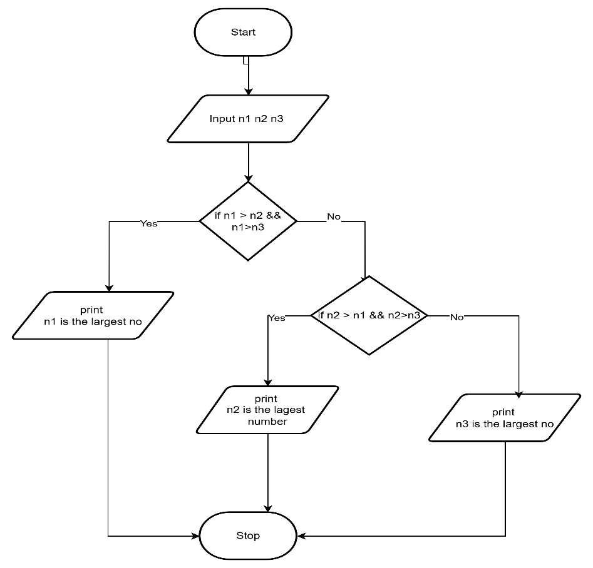
CODETANTRA:
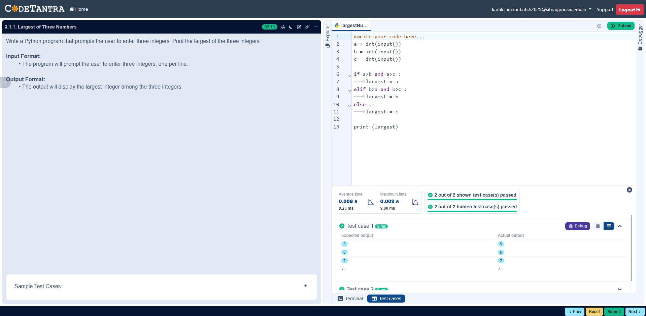
3.1.2//Celsius to farehinheit
ALGORITHM:
Step 1: Start
Step 2: Read temperature in Celsius → C
Step 3: Calculate Fahrenheit using the formula
$$F=(C×\frac{9}{5})+32$$
Step 4: Display value of F
Step 5: Stop
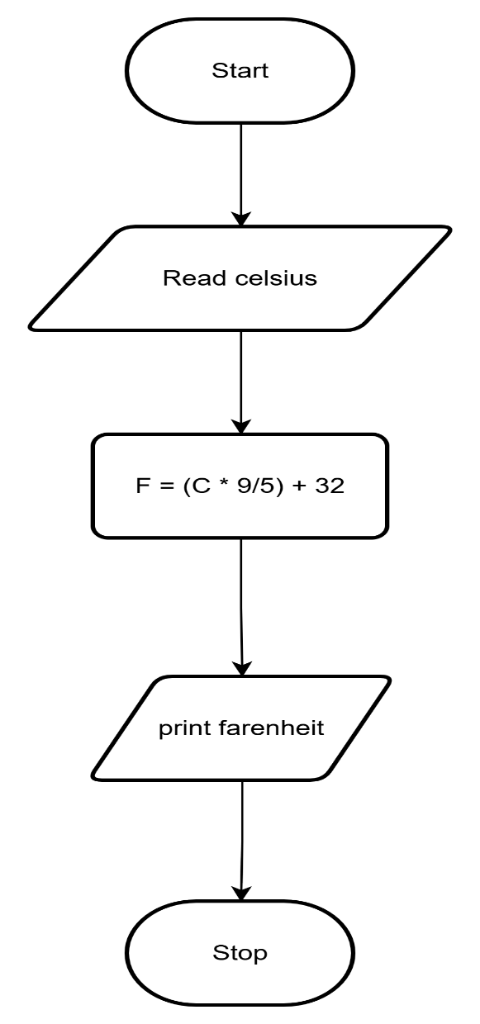
FLOWCHART:
CODETANTRA:
